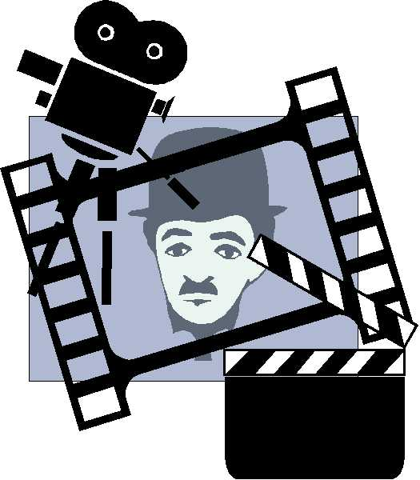

**Guião**

**Filmes e documentários**

1. **Ficha técnica**
2. Título: ________________________________________________________________
3. Realização: ____________________________________________________________
4. Atores principais: _______________________________________________________
5. Ano de realização: _________________ Duração: ____________________
6. Banda sonora: _________________________________________________

**C. Breve resumo**

_____________________________________________________________________________________________________________________________________________________________________________________________________________________________________________________________________________________________________________________________________________________________________________________________________________________________________________________________________________________________________________________________________________

**B. Género**

1. Drama
2. Comédia
3. Ação
4. Histórico
5. Aventura
6. Romance
7. Guerra
8. Policial
9. Terror
10. Animação
11. Documentário
12. Ficção científica
13. Outro

Qual? _____________

**D.** **Comentário (ligação com os conteúdos lecionados)**

______________________________________________________________________________________________________________________________________________________________________________________________________________________________________________________________________________________________________________________________________________________________________________________________________________________________________________________________________________________________________________________________________________________________________________________________________________________________________________________________________________________________________________________________________________________________________________________________________