Atalhos SHIFT+ Simbolos
SHIFT+F3 Change the text in Microsoft Word from uppercase to lowercase or a capital letter at the beginning of every word.
SHIFT+F3 Altera o texto selecionado para maiúsculas ou para minúsculas.
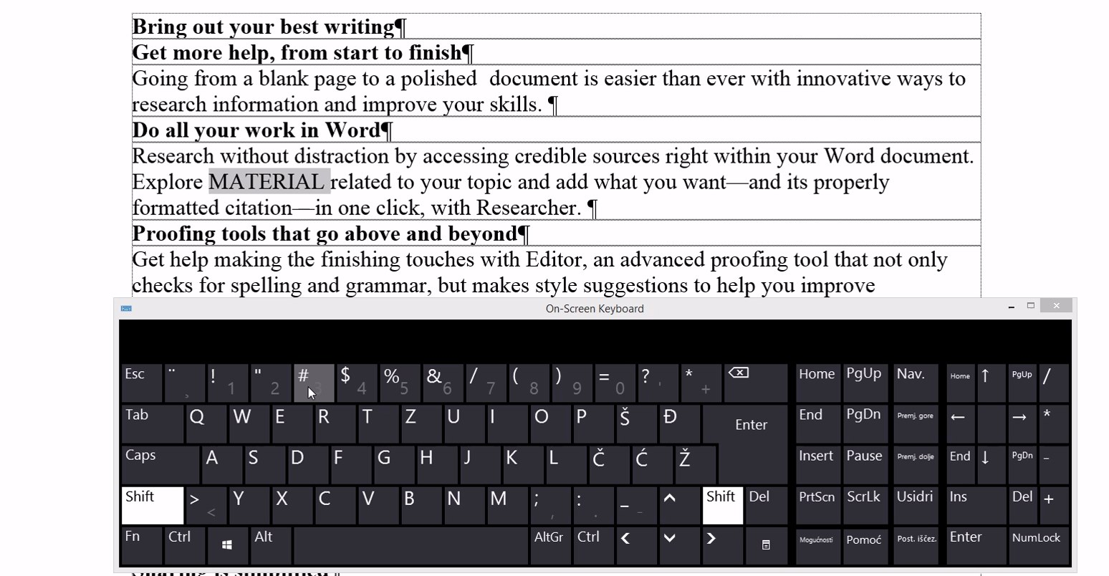
https://sway.office.com/S2TpzZcxSa72wJ9N#content=TRCuBKGp7xhE9E
1 - SHIFT+F3
SHIFT+F7 Runs a Thesaurus check on the selected word.
SHIFT+F7 Abre o dicionário de sinónimos
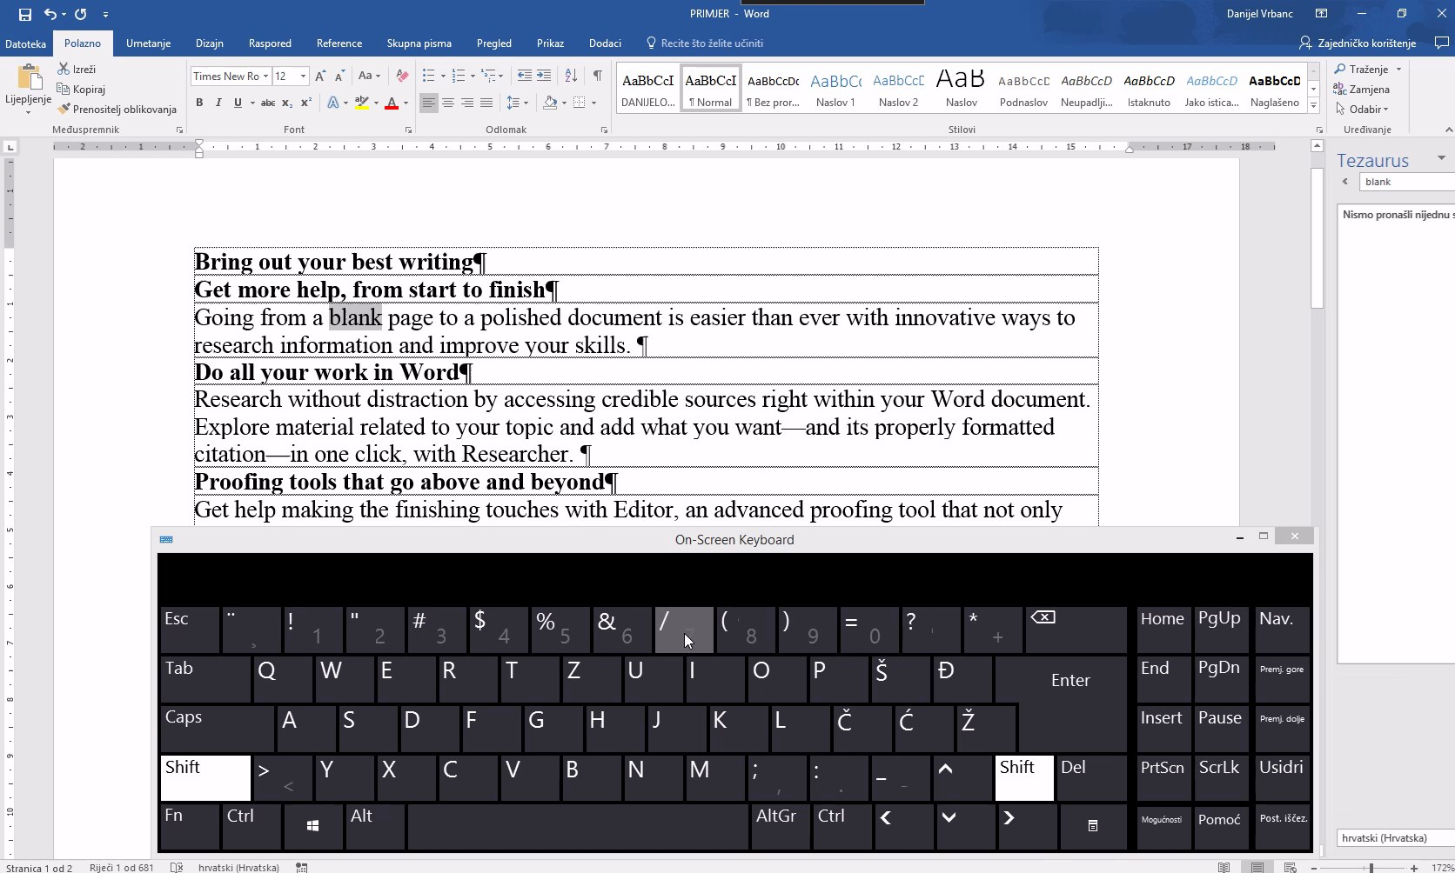
https://sway.office.com/S2TpzZcxSa72wJ9N#content=INQ5lXoqNUr6KF
2 - SHIFT+F7
SHIFT+F12 Save the open document. Just like Ctrl+S.
SHIFT+F12 Guarda o documento.Tal como Ctrl+G
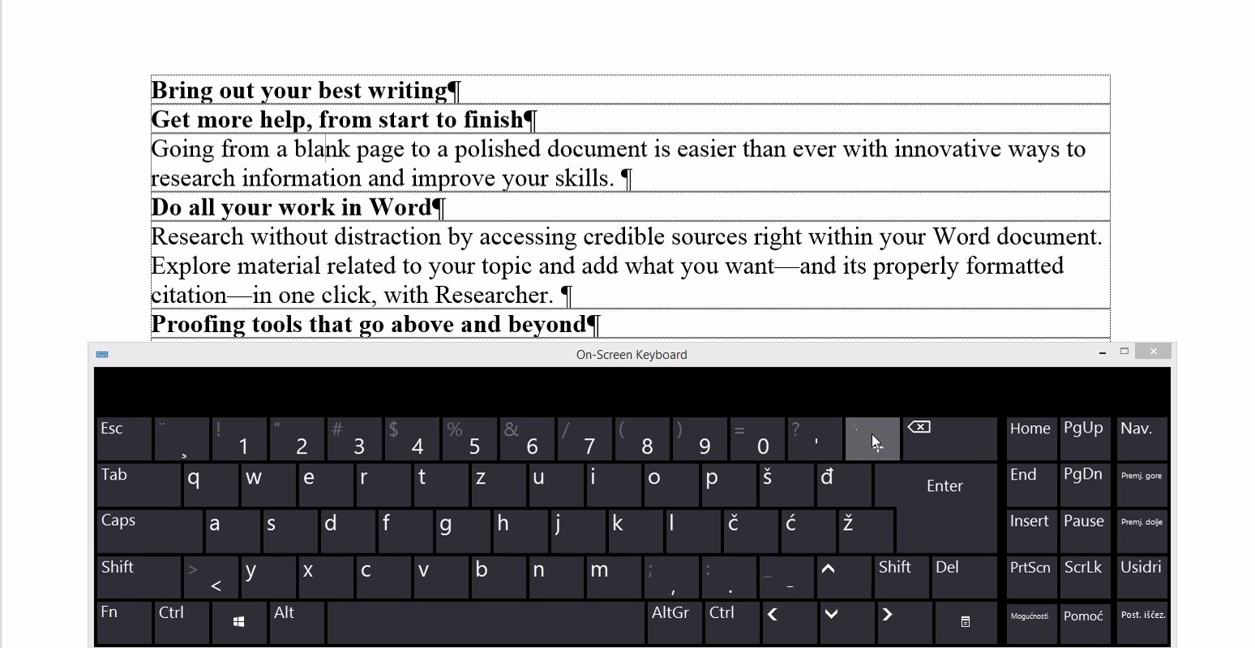
https://sway.office.com/S2TpzZcxSa72wJ9N#content=b4a7yTn6jINqgD
3 - SHIFT+F12
SHIFT+Enter Create a soft break instead of a new paragraph.
SHIFT+Enter Cria quebra "suave", não necessária mente um novo parágrafo.
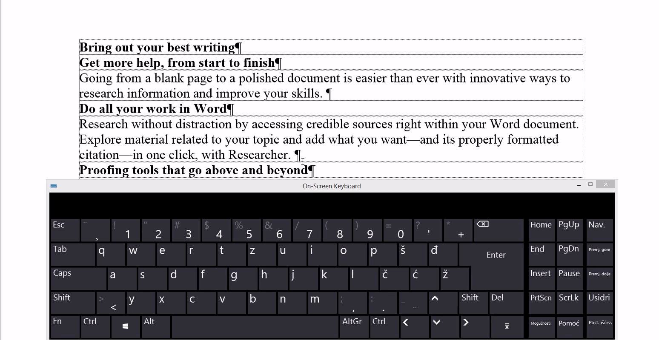
https://sway.office.com/S2TpzZcxSa72wJ9N#content=Xw7RWTz7xXM2HI
4 - SHIFT+Enter
SHIFT+Alt+D Insert the current date.
SHIFT+Alt+D Insere a data actual.
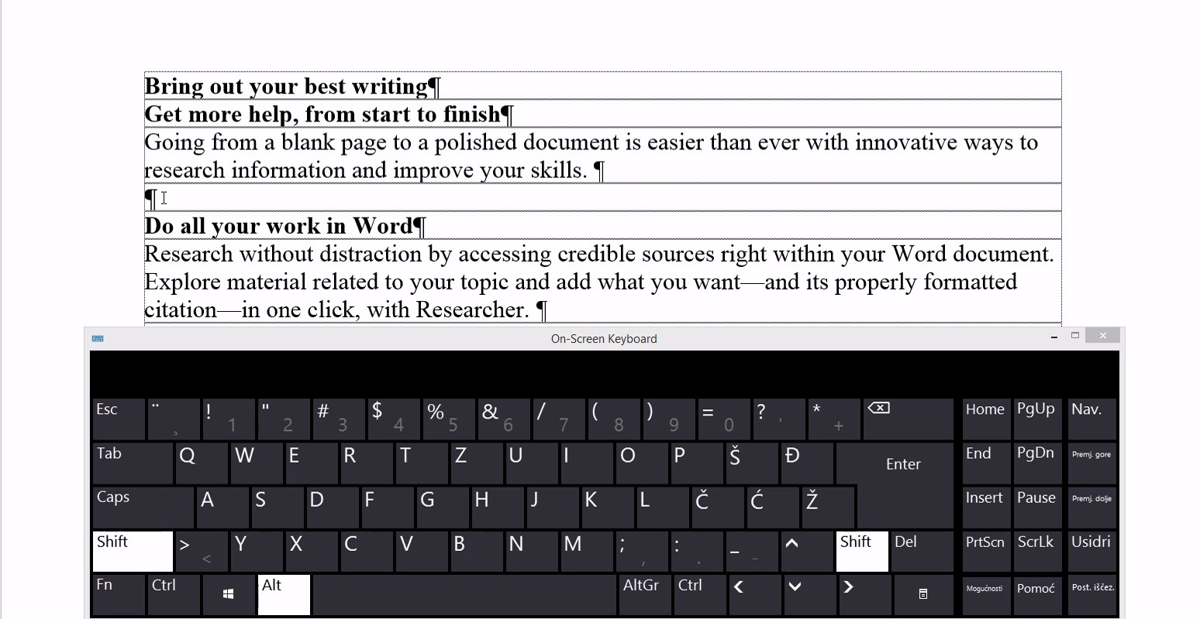
https://sway.office.com/S2TpzZcxSa72wJ9N#content=dqaS8P9hyXn1Wq
5 - SHIFT+Alt+D
SHIFT+Alt+T Insert the current time.
SHIFT+Alt+T Insere a hora Actual.
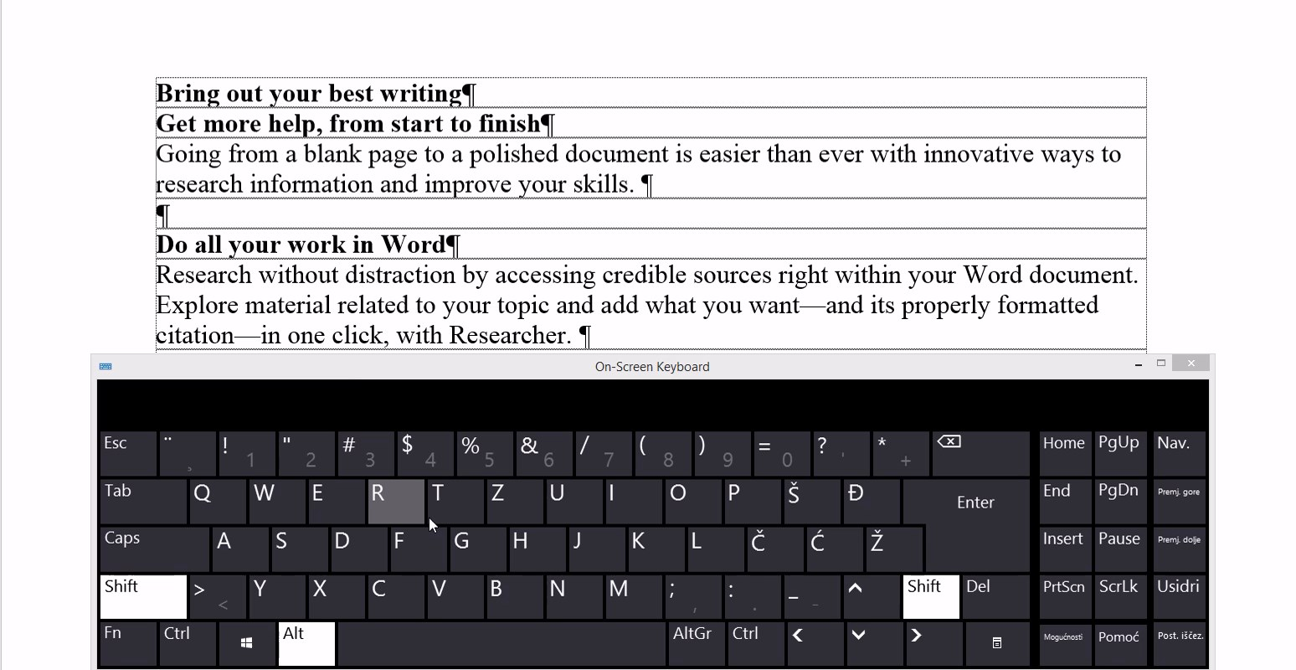
https://sway.office.com/S2TpzZcxSa72wJ9N#content=b1fwd7hoPjRIlB
6 - SHIFT+Alt+T

