Atalhos CTRL+letra (N-Z)
CTRL+N opens new, blank document window.
CTRL+N Coloca a Negrito o texto selecionado.
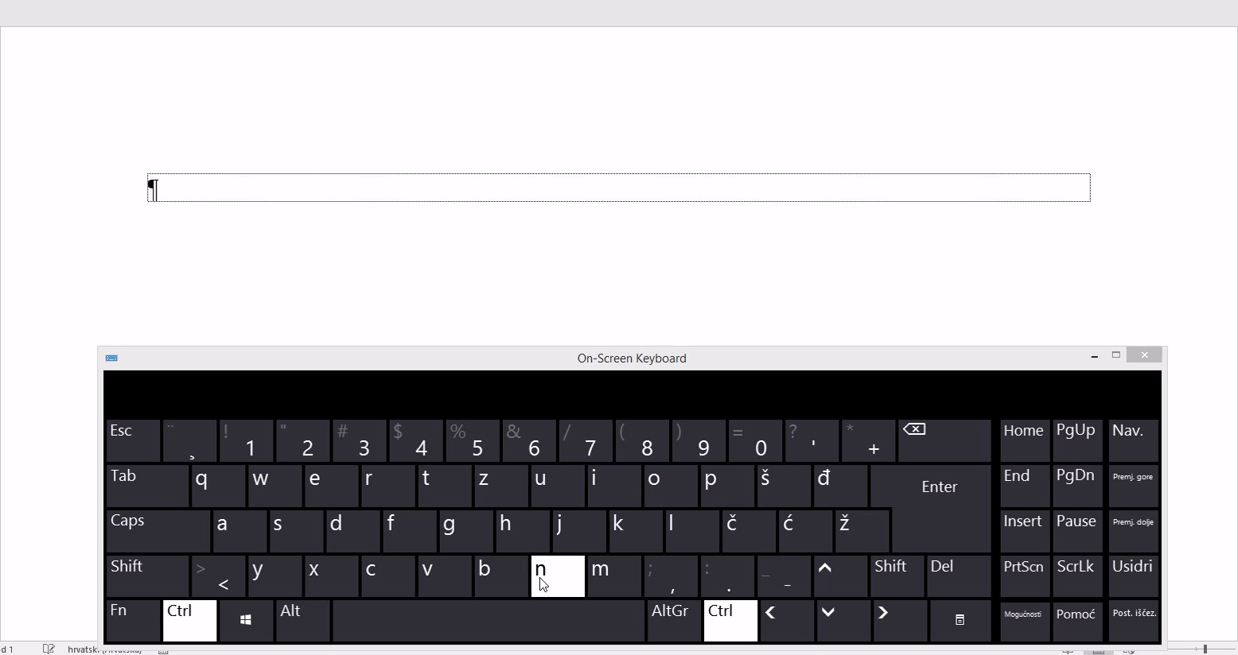
https://sway.office.com/JnVOgN0GdBj6atJ5#content=OIh9Vg10XYOLVS
1 - CTRL+N opens new, blank document window.
CTRL+O opens the dialog box or page for selecting a file to open.
CTRL+O Abre um documento Word em branco.
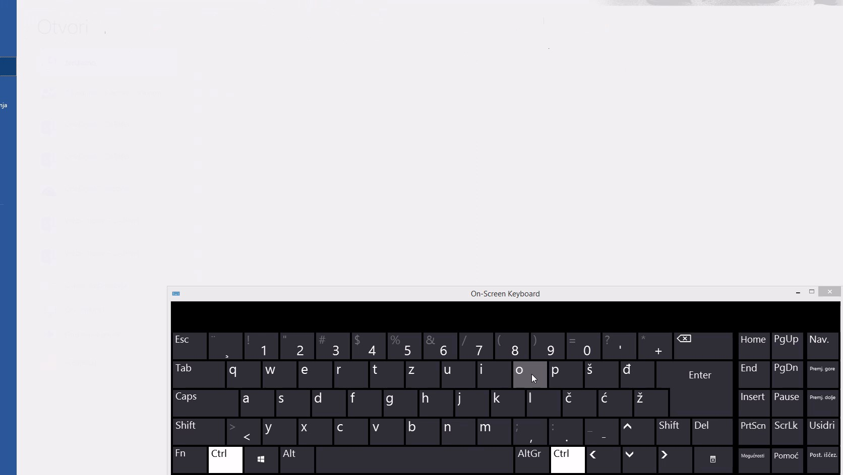
https://sway.office.com/JnVOgN0GdBj6atJ5#content=iaNxKV8Un9is3w
2 - CTRL+O opens the dialog box or page for selecting a file to open.
CTRL+P open the print window.
CTRL+P Abre o menu de impressão.
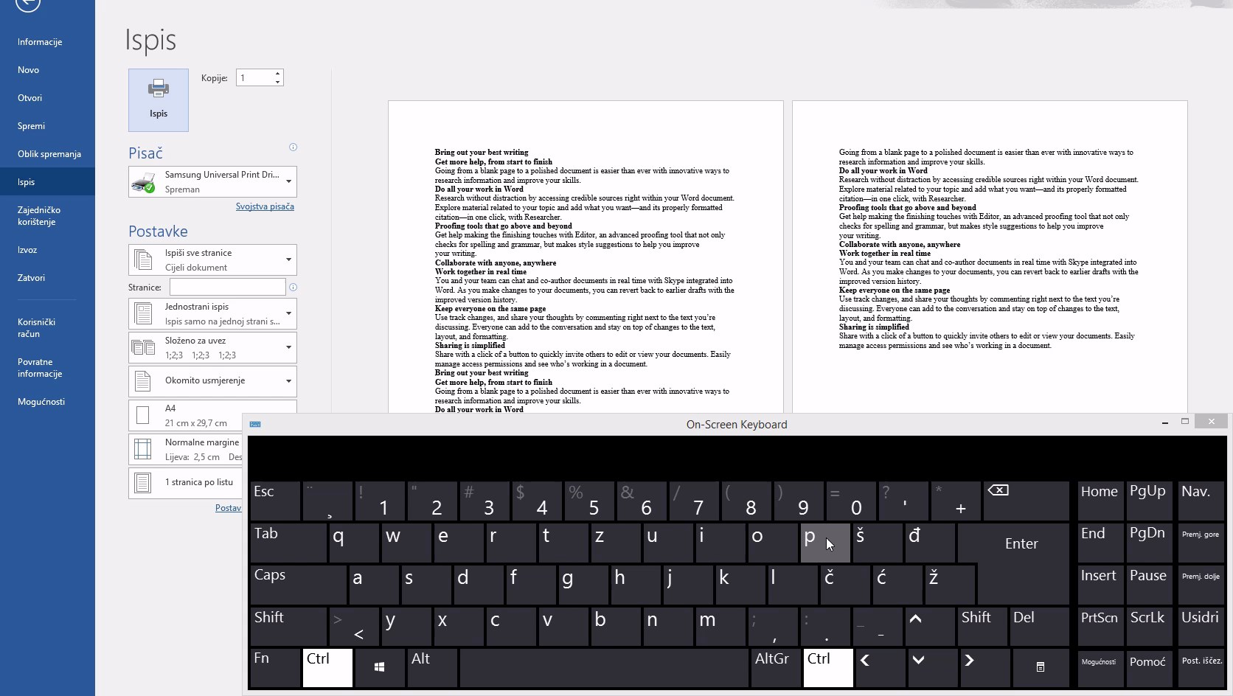
https://sway.office.com/JnVOgN0GdBj6atJ5#content=5gYOzcqJiobuaU
3 - CTRL+P open the print window..
CTRL+R aligns the line or selected text to the right of the screen.
CTRL+R Refaz a última acção.
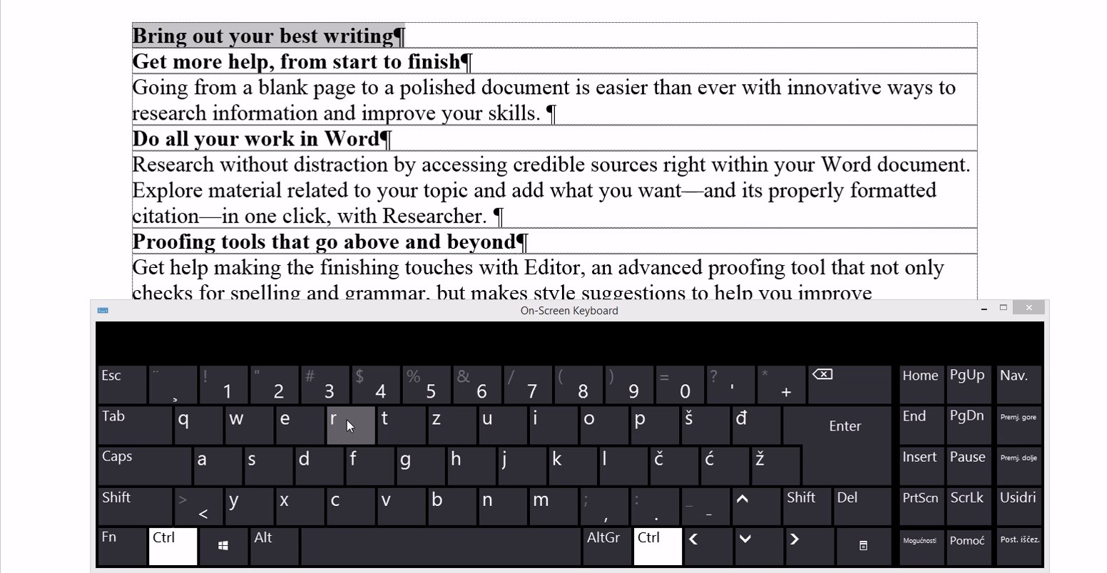
https://sway.office.com/JnVOgN0GdBj6atJ5#content=jHWpserndHQqLp
4 - CTRL+R aligns the line or selected text to the right of the screen.
CTRL+S Save the open document. Just like Shift+F12.
CTRL+S Sublinha o texto selecionado.
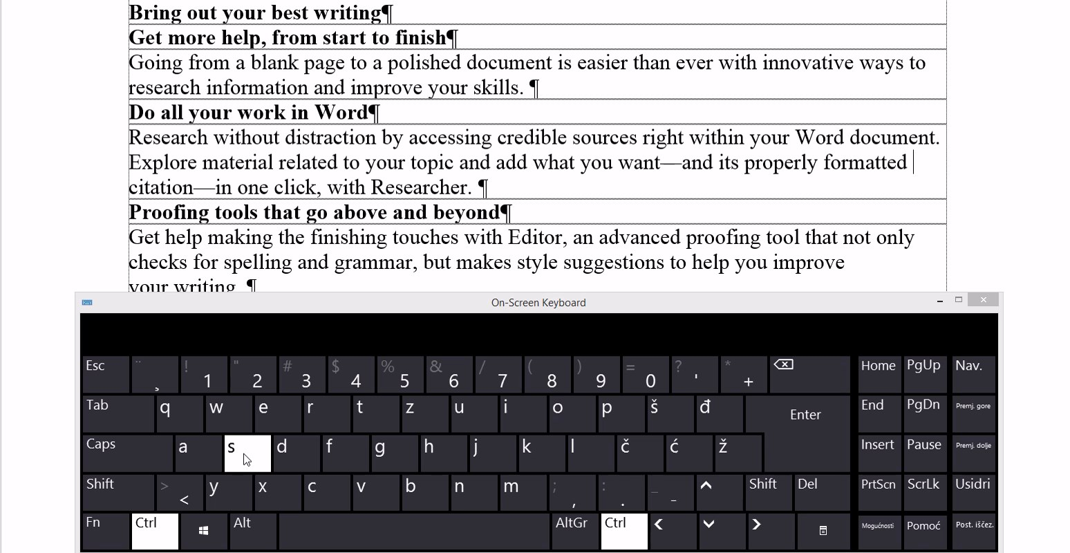
https://sway.office.com/JnVOgN0GdBj6atJ5#content=Q3vmMspoHQwUTL
5 - CTRL+S Save the open document. Just like Shift+F12.
CTRL+T Create a hanging indent.
CTRL+T Seleciona todo o documento.
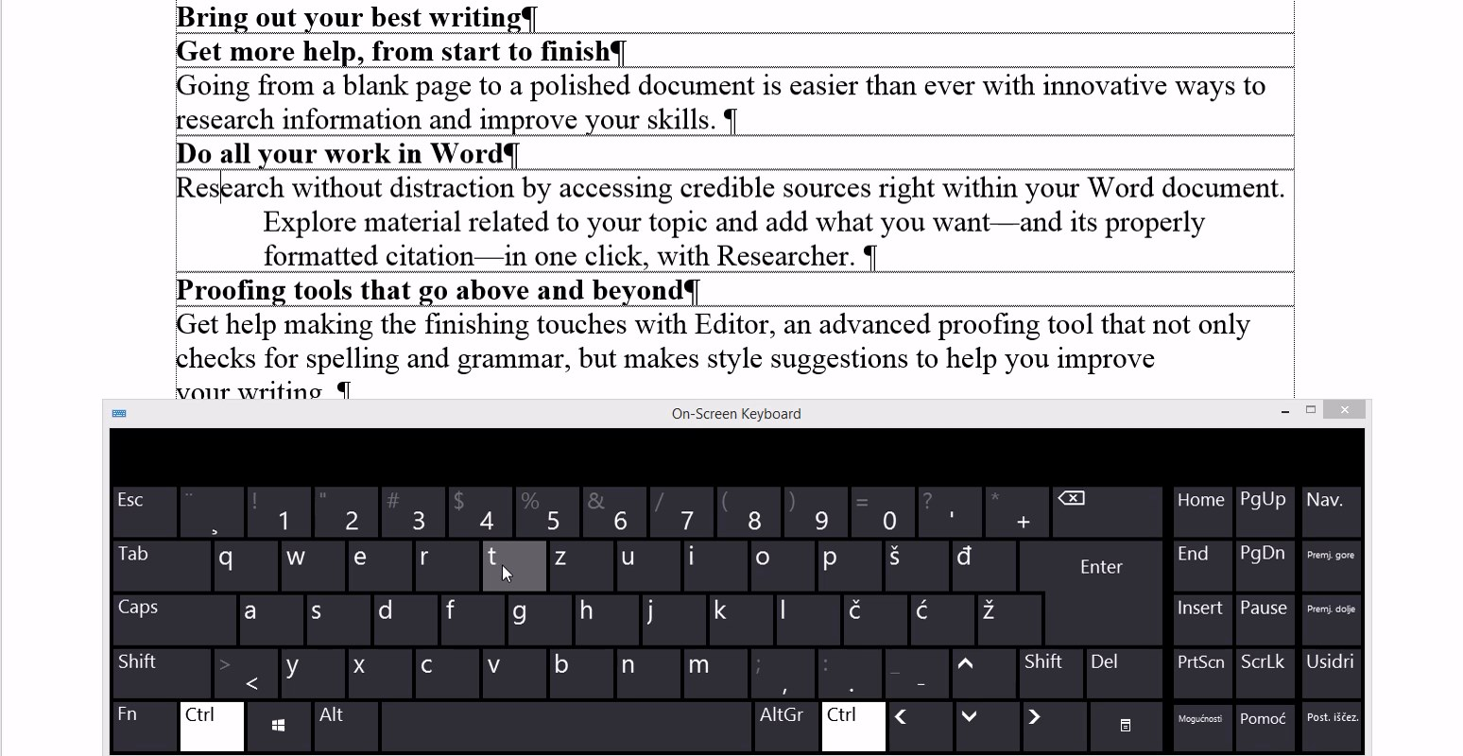
https://sway.office.com/JnVOgN0GdBj6atJ5#content=I2ZrgV4ffj7N6h
6 - CTRL+T Create a hanging indent.
CTRL+U Underline the selected text.
CTRL+U Abre a janela de Localizar e substituir.
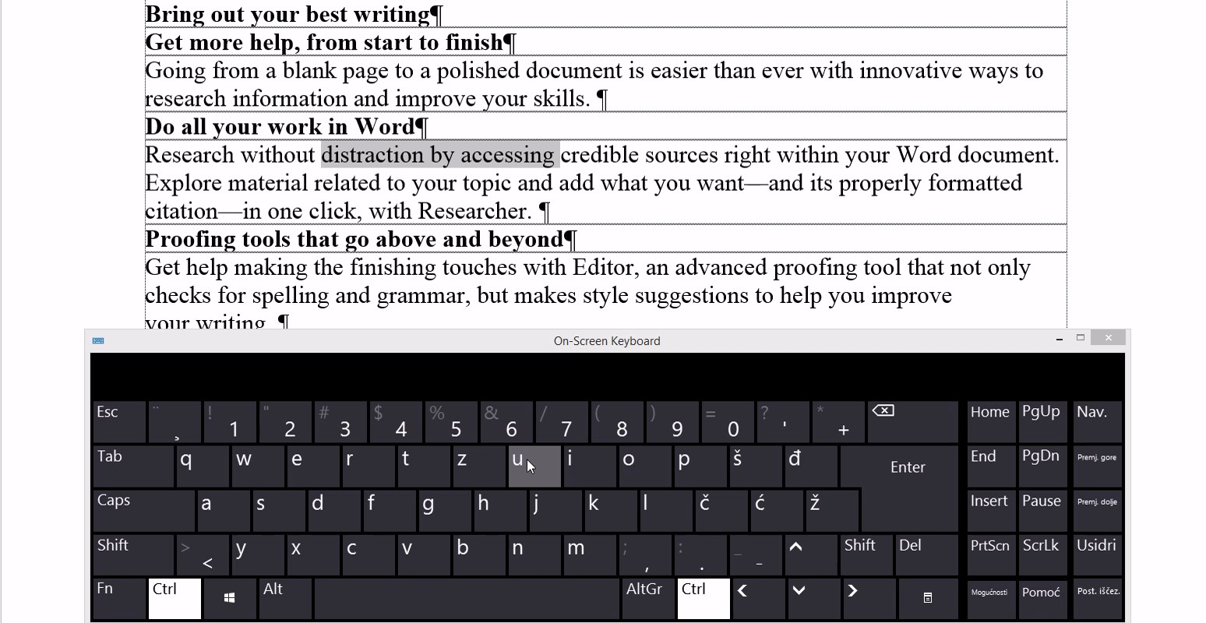
https://sway.office.com/JnVOgN0GdBj6atJ5#content=07iUyGKcz4Y031
7 - CTRL+U Underline the selected text.
CTRL+C and CTRL+V Copy and Paste.
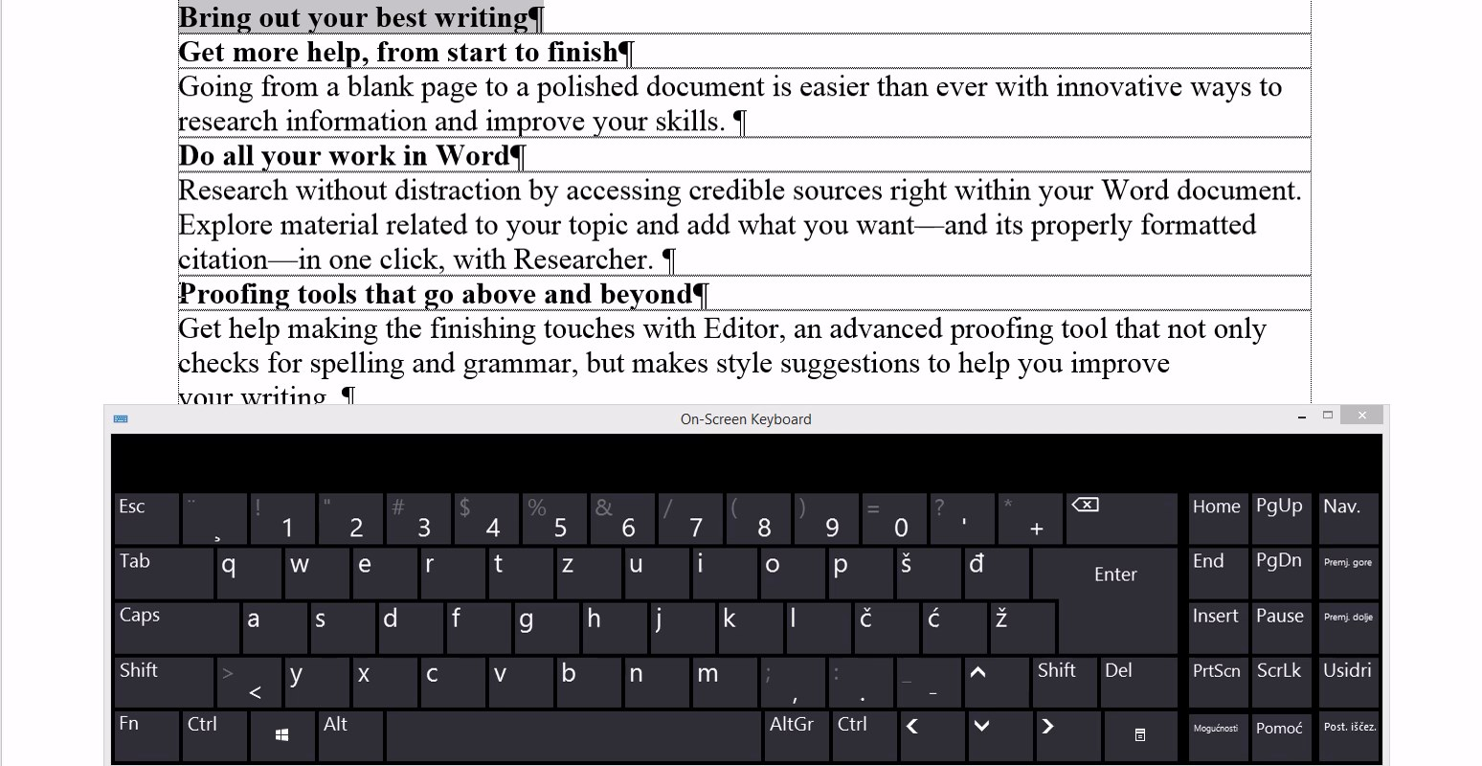
https://sway.office.com/JnVOgN0GdBj6atJ5#content=ak9orFT2Lqtkld
8 - CTRL+C and CTRL+V Copy and Paste.
CTRL+X and CTRL+V Cut selected text and paste it.
CTRL+X e CTRL+V Corta o texto selecionado e cola.
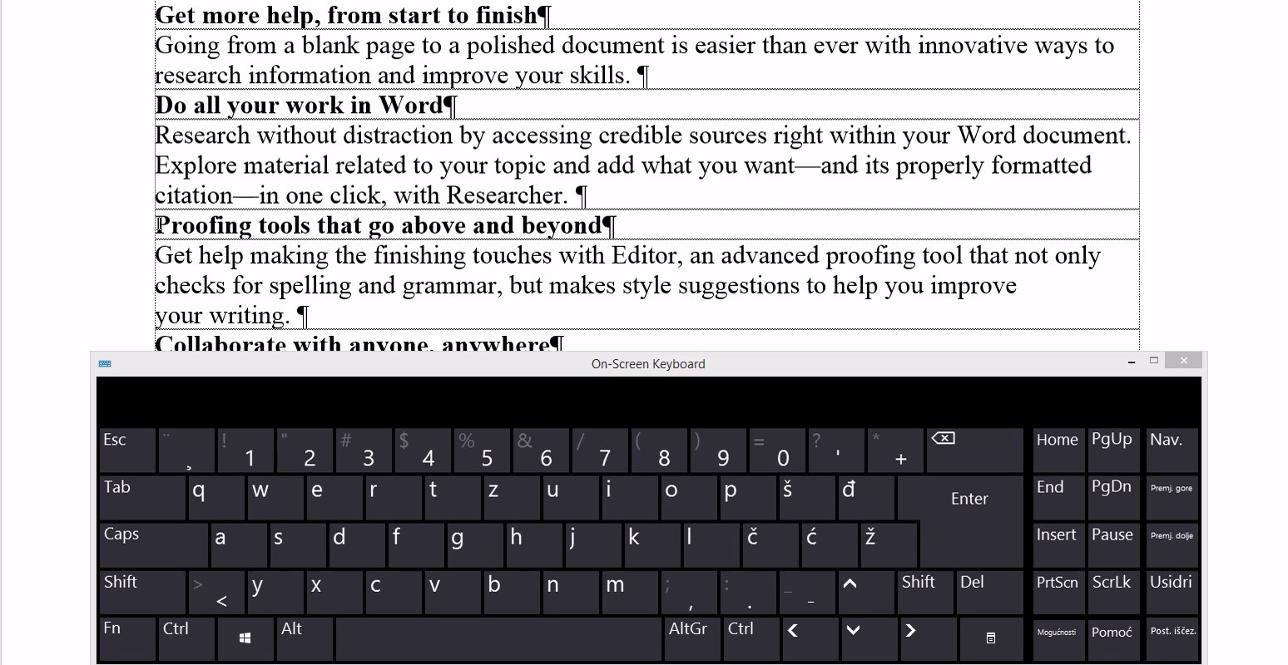
https://sway.office.com/JnVOgN0GdBj6atJ5#content=KQxjJQguJFLFbY
9 - CTRL+X and CTRL+V Cut selected text and paste it.
On the end - standard shortcuts like in the other program languages or tools:
CTRL+Y Redo the last action performed.
CTRL+Y Alinha o texto ao centro.
CTRL+Z Undo the last action.
CTRL+Z Desfaz a última acção.

